# Name: Mandavi Dubey

Year/Sem: **SE Sem 4**

Div: **A**

# UID No.: 120CP1122B

Roll No.: **23**

* **Experiment No. 2**

**Aim:**   
In this experiment the Student will be able to understand the basics of functions used in Python programming language with the help of a iterative simulator.

**Platform:**<http://vlabs.iitb.ac.in/vlabs-dev/labs/python-basics/index.html>

**Code & Output:**

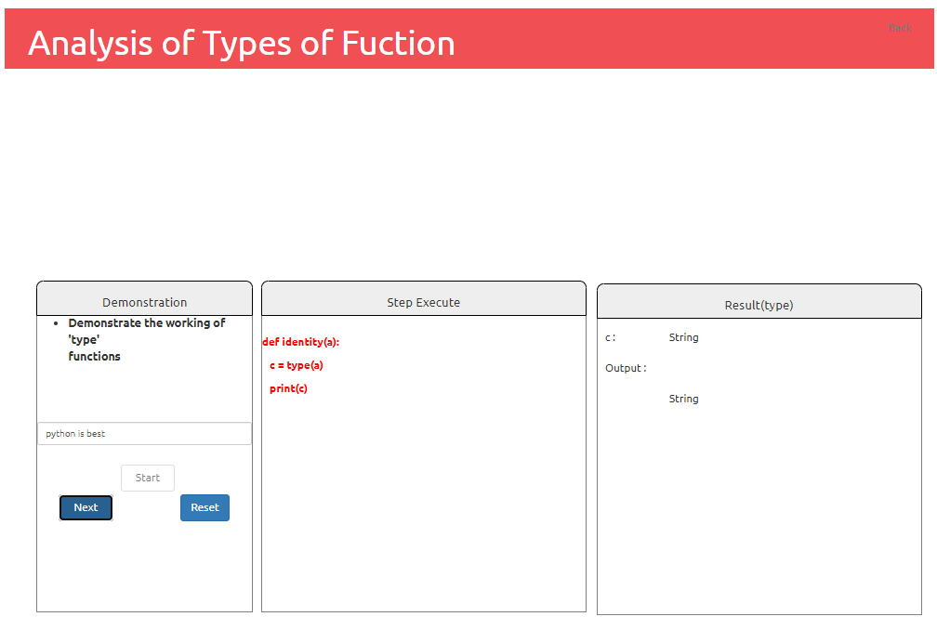

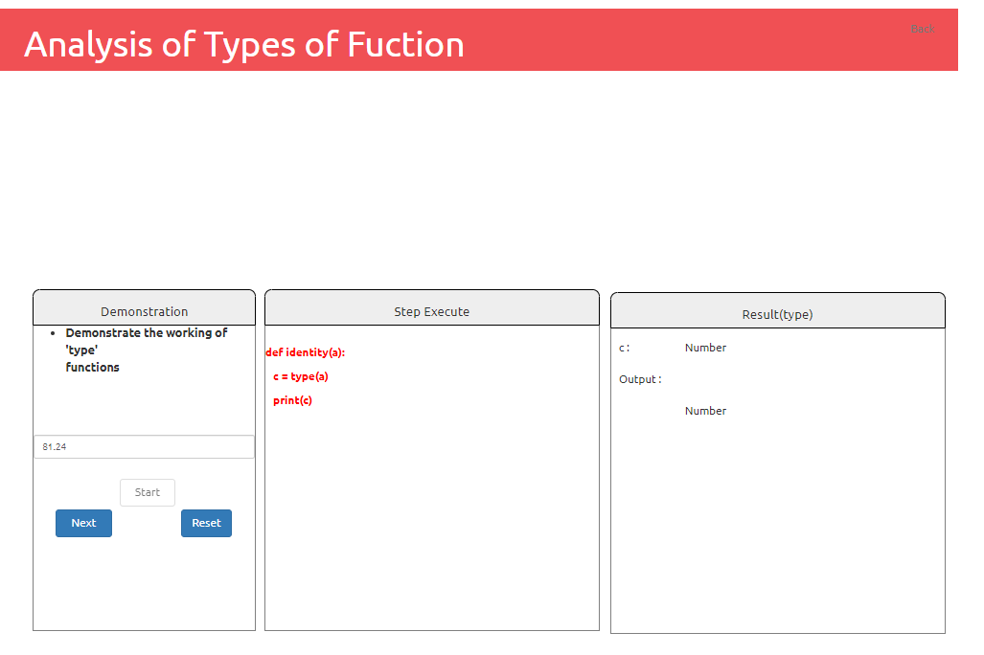

a) Integer :

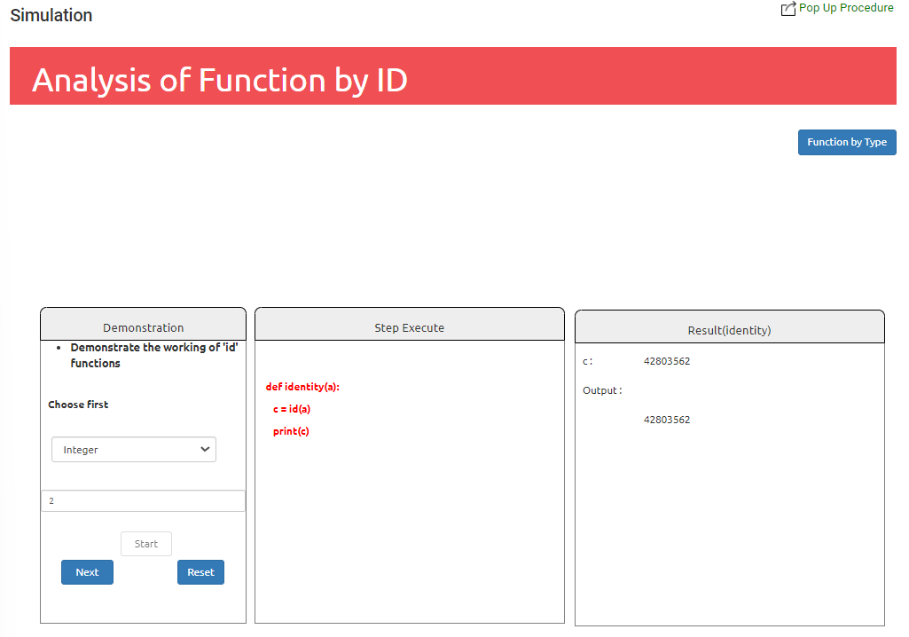

b) Float:

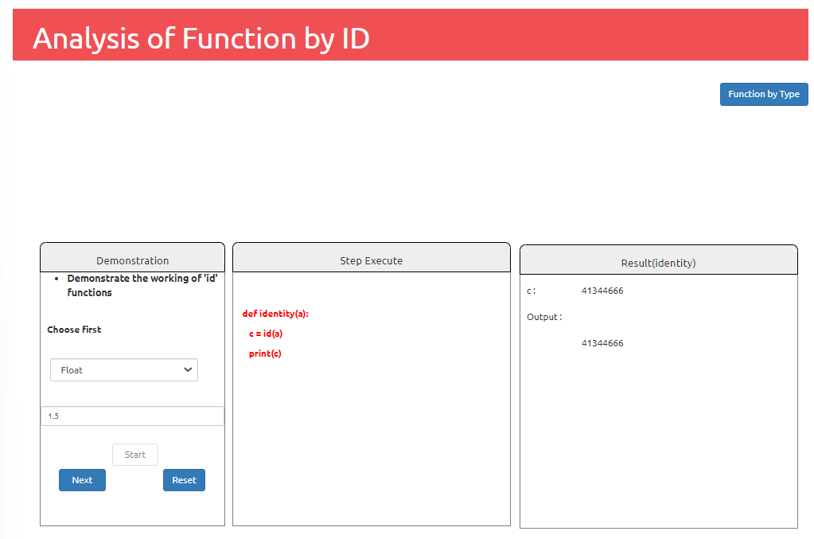

c) String :

